MERN Application through Terraform and Ansible
MERN Application through Terraform and Ansible
Name: Saranya S ID: 13487
Date: 02nd Aug 2026

Documentation

Create an IAM user for Terraform:
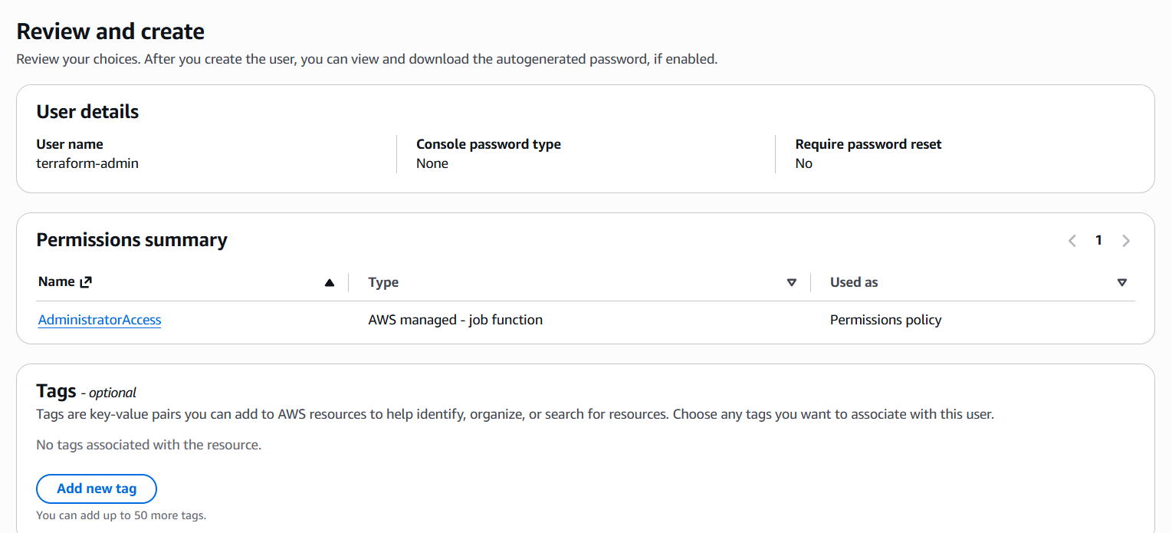
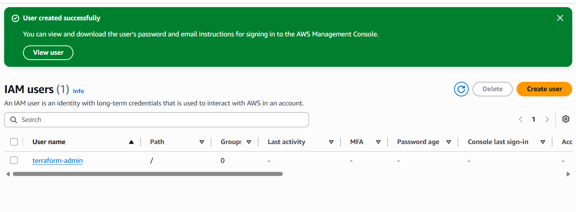
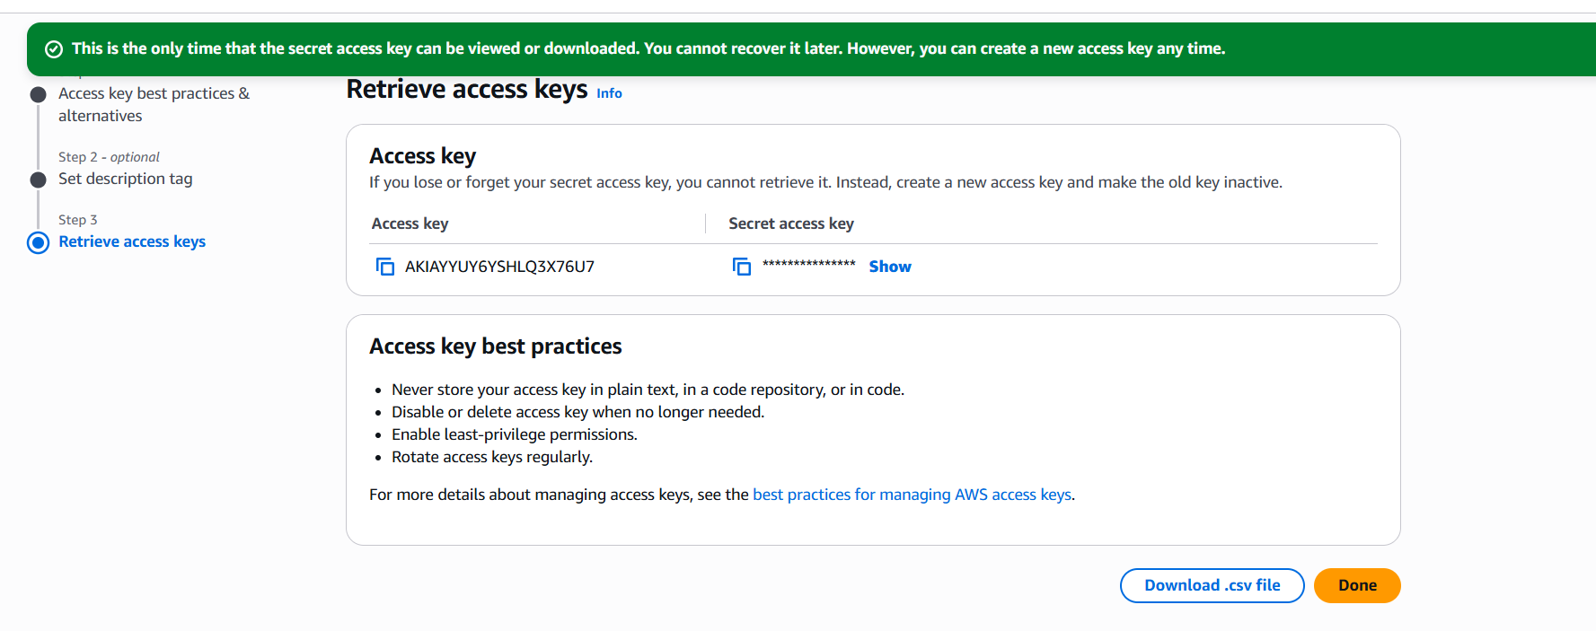
AWS CLI:
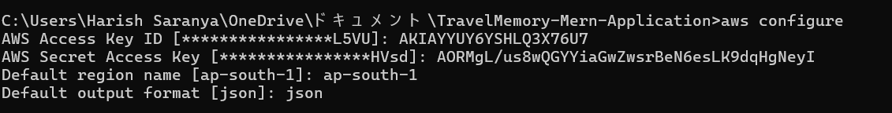
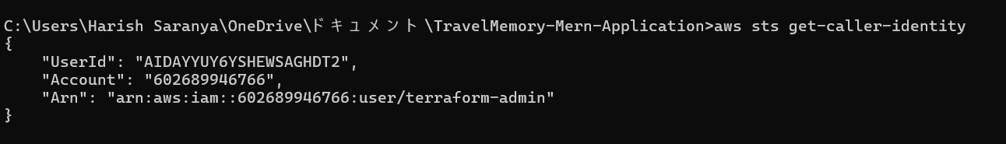
Install Terraform on Windows:
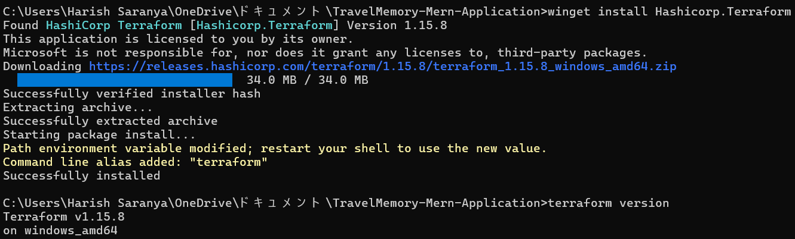
Create Terraform folders:
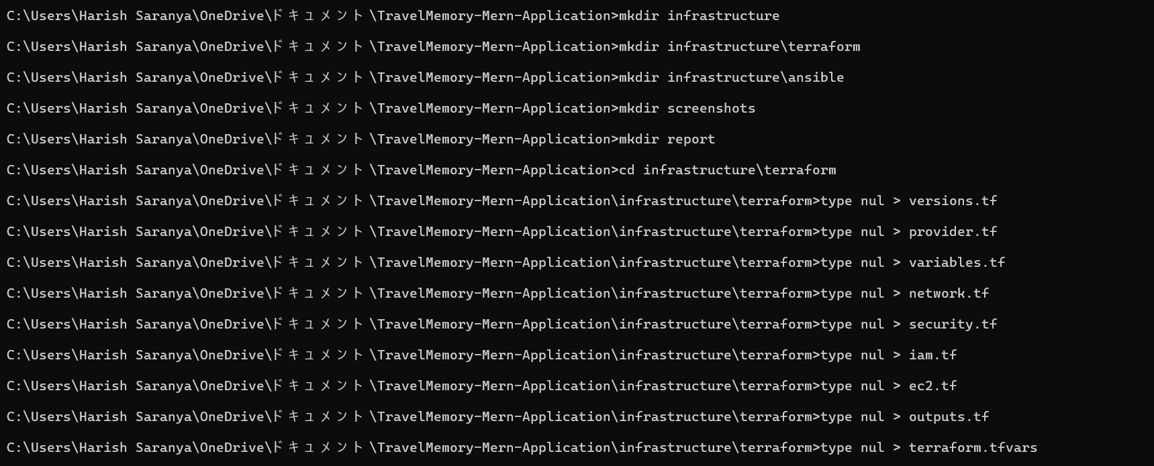
Add Terraform configuration:
versions.tf
terraform {
required_version = ">= 1.5.0"
required_providers {
aws = {
source = "hashicorp/aws"
version = "~> 6.0"
}
}
}
provider.tf
provider "aws" {
region = var.aws_region

default_tags {
tags = {
Project = "TravelMemory"
Environment = "Assignment"
ManagedBy = "Terraform"
}
}
}variables.tf
variable "aws_region" {
description = "AWS region"
type = string
default = "ap-south-1"
}

variable "availability_zone" {
description = "Availability Zone"
type = string
default = "ap-south-1a"
}

variable "vpc_cidr" {
description = "VPC CIDR range"
type = string
default = "10.0.0.0/16"
}

variable "public_subnet_cidr" {
description = "Public subnet CIDR"
type = string
default = "10.0.1.0/24"
}

variable "private_subnet_cidr" {
description = "Private subnet CIDR"
type = string
default = "10.0.2.0/24"
}

variable "my_ip" {
description = "Your public IP in CIDR format"
type = string
}

variable "key_name" {
description = "Existing AWS EC2 key pair"
type = string
default = "travelmemory-key"
}

variable "instance_type" {
description = "EC2 instance type"
type = string
default = "t3.micro"
}
terraform.tfvars
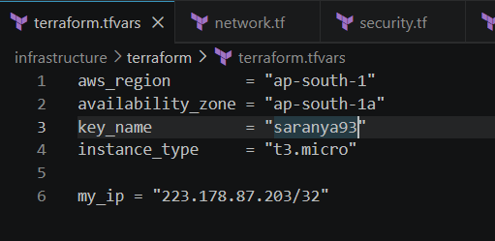
network.tf
resource "aws_vpc" "travelmemory_vpc" {
cidr_block = var.vpc_cidr
enable_dns_support = true
enable_dns_hostnames = true

tags = {
Name = "travelmemory-vpc"
}
}

resource "aws_internet_gateway" "travelmemory_igw" {
vpc_id = aws_vpc.travelmemory_vpc.id

tags = {
Name = "travelmemory-igw"
}
}

resource "aws_subnet" "public_subnet" {
vpc_id = aws_vpc.travelmemory_vpc.id
cidr_block = var.public_subnet_cidr
availability_zone = var.availability_zone
map_public_ip_on_launch = true

tags = {
Name = "travelmemory-public-subnet"
}
}

resource "aws_subnet" "private_subnet" {
vpc_id = aws_vpc.travelmemory_vpc.id
cidr_block = var.private_subnet_cidr
availability_zone = var.availability_zone
map_public_ip_on_launch = false

tags = {
Name = "travelmemory-private-subnet"
}
}

resource "aws_eip" "nat_eip" {
domain = "vpc"

depends_on = [
aws_internet_gateway.travelmemory_igw
]

tags = {
Name = "travelmemory-nat-eip"
}
}

resource "aws_nat_gateway" "travelmemory_nat" {
allocation_id = aws_eip.nat_eip.id
subnet_id = aws_subnet.public_subnet.id

depends_on = [
aws_internet_gateway.travelmemory_igw
]

tags = {
Name = "travelmemory-nat-gateway"
}
}

resource "aws_route_table" "public_route_table" {
vpc_id = aws_vpc.travelmemory_vpc.id

route {
cidr_block = "0.0.0.0/0"
gateway_id = aws_internet_gateway.travelmemory_igw.id
}

tags = {
Name = "travelmemory-public-route-table"
}
}

resource "aws_route_table_association" "public_route_association" {
subnet_id = aws_subnet.public_subnet.id
route_table_id = aws_route_table.public_route_table.id
}

resource "aws_route_table" "private_route_table" {
vpc_id = aws_vpc.travelmemory_vpc.id

route {
cidr_block = "0.0.0.0/0"
nat_gateway_id = aws_nat_gateway.travelmemory_nat.id
}

tags = {
Name = "travelmemory-private-route-table"
}
}

resource "aws_route_table_association" "private_route_association" {
subnet_id = aws_subnet.private_subnet.id
route_table_id = aws_route_table.private_route_table.id
}
Create security groups:
resource "aws_security_group" "web_sg" {
name = "travelmemory-web-sg"
description = "Security group for TravelMemory web server"
vpc_id = aws_vpc.travelmemory_vpc.id

ingress {
description = "SSH only from administrator IP"
from_port = 22
to_port = 22
protocol = "tcp"
cidr_blocks = [var.my_ip]
}

ingress {
description = "HTTP from internet"
from_port = 80
to_port = 80
protocol = "tcp"
cidr_blocks = ["0.0.0.0/0"]
}

ingress {
description = "Temporary direct backend access"
from_port = 3000
to_port = 3000
protocol = "tcp"
cidr_blocks = [var.my_ip]
}

egress {
description = "Allow all outbound traffic"
from_port = 0
to_port = 0
protocol = "-1"
cidr_blocks = ["0.0.0.0/0"]
}

tags = {
Name = "travelmemory-web-sg"
}
}

resource "aws_security_group" "database_sg" {
name = "travelmemory-database-sg"
description = "Security group for private MongoDB server"
vpc_id = aws_vpc.travelmemory_vpc.id

ingress {
description = "SSH from web server only"
from_port = 22
to_port = 22
protocol = "tcp"
security_groups = [aws_security_group.web_sg.id]
}

ingress {
description = "MongoDB from web server only"
from_port = 27017
to_port = 27017
protocol = "tcp"
security_groups = [aws_security_group.web_sg.id]
}

egress {
description = "Allow outbound traffic through NAT Gateway"
from_port = 0
to_port = 0
protocol = "-1"
cidr_blocks = ["0.0.0.0/0"]
}

tags = {
Name = "travelmemory-database-sg"
}
}
Add IAM role:
resource "aws_iam_role" "ec2_role" {
name = "travelmemory-ec2-role"

assume_role_policy = jsonencode({
Version = "2012-10-17"

Statement = [
{
Effect = "Allow"

Principal = {
Service = "ec2.amazonaws.com"
}

Action = "sts:AssumeRole"
}
]
})
}

resource "aws_iam_role_policy_attachment" "ssm_policy" {
role = aws_iam_role.ec2_role.name
policy_arn = "arn:aws:iam::aws:policy/AmazonSSMManagedInstanceCore"
}

resource "aws_iam_instance_profile" "ec2_profile" {
name = "travelmemory-ec2-profile"
role = aws_iam_role.ec2_role.name
}

Create EC2 instances:
data "aws_ami" "ubuntu" {
most_recent = true
owners = ["099720109477"]

filter {
name = "name"

values = [
"ubuntu/images/hvm-ssd-gp3/ubuntu-noble-24.04-amd64-server-*"
]
}

filter {
name = "virtualization-type"
values = ["hvm"]
}

filter {
name = "architecture"
values = ["x86_64"]
}
}

resource "aws_instance" "web_server" {
ami = data.aws_ami.ubuntu.id
instance_type = var.instance_type
subnet_id = aws_subnet.public_subnet.id
vpc_security_group_ids = [aws_security_group.web_sg.id]
key_name = var.key_name
associate_public_ip_address = true
iam_instance_profile = aws_iam_instance_profile.ec2_profile.name

root_block_device {
volume_size = 15
volume_type = "gp3"
encrypted = true
}

metadata_options {
http_endpoint = "enabled"
http_tokens = "required"
}

tags = {
Name = "travelmemory-web-server"
Role = "Web"
}
}

resource "aws_instance" "database_server" {
ami = data.aws_ami.ubuntu.id
instance_type = var.instance_type
subnet_id = aws_subnet.private_subnet.id
vpc_security_group_ids = [aws_security_group.database_sg.id]
key_name = var.key_name
associate_public_ip_address = false
iam_instance_profile = aws_iam_instance_profile.ec2_profile.name

root_block_device {
volume_size = 15
volume_type = "gp3"
encrypted = true
}

metadata_options {
http_endpoint = "enabled"
http_tokens = "required"
}

depends_on = [
aws_nat_gateway.travelmemory_nat,
aws_route_table_association.private_route_association
]

tags = {
Name = "travelmemory-database-server"
Role = "Database"
}
}
Add Terraform outputs:
output "web_server_public_ip" {
description = "Public IP of the web server"
value = aws_instance.web_server.public_ip
}

output "web_server_private_ip" {
description = "Private IP of the web server"
value = aws_instance.web_server.private_ip
}

output "database_server_private_ip" {
description = "Private IP of the MongoDB server"
value = aws_instance.database_server.private_ip
}

output "web_server_public_dns" {
description = "Public DNS of the web server"
value = aws_instance.web_server.public_dns
}

output "ssh_command" {
description = "Command to connect to the public web server"
value = "ssh -i ~/.ssh/travelmemory-key.pem ubuntu@${aws_instance.web_server.public_ip}"
}
Run Terraform:
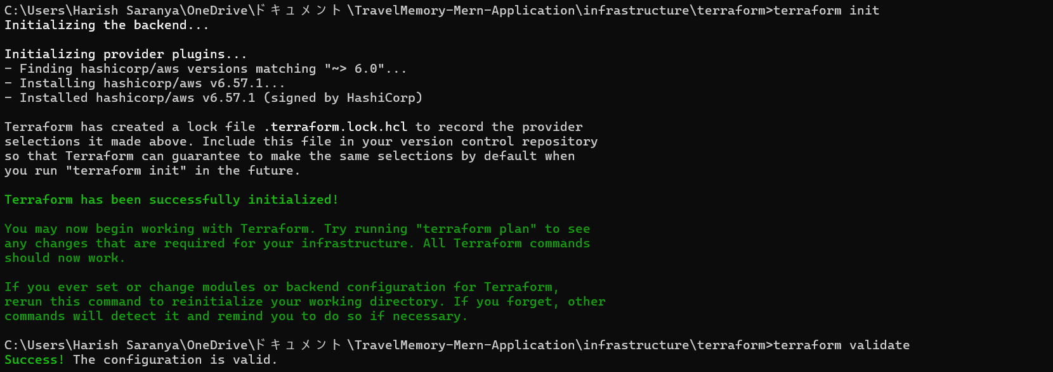
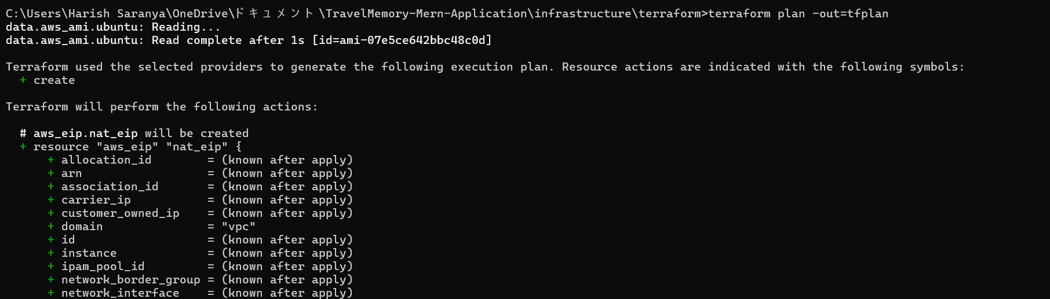
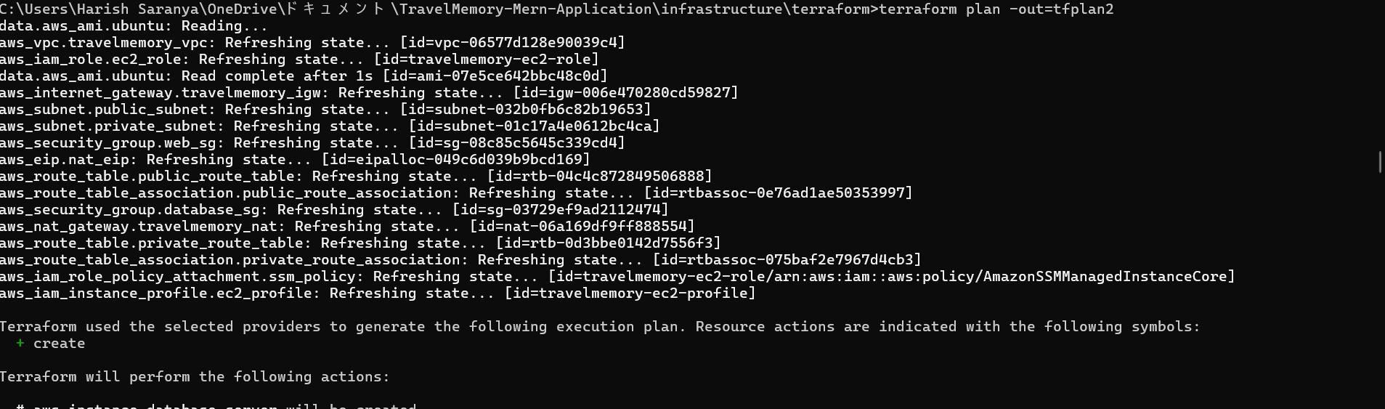
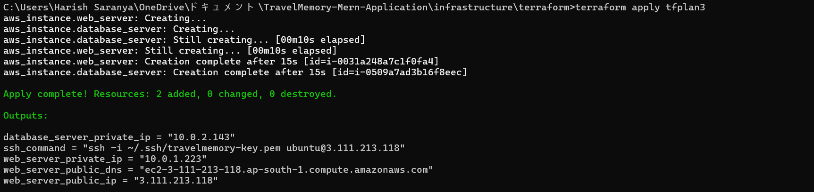
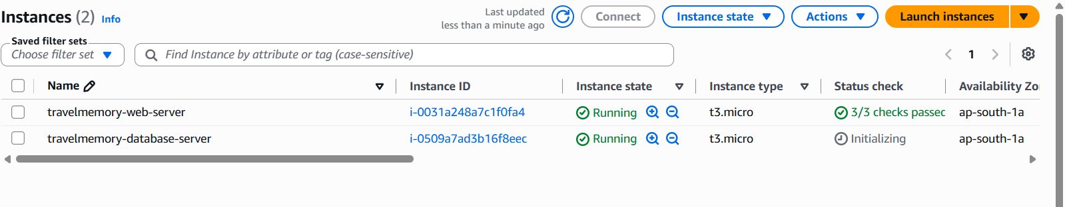
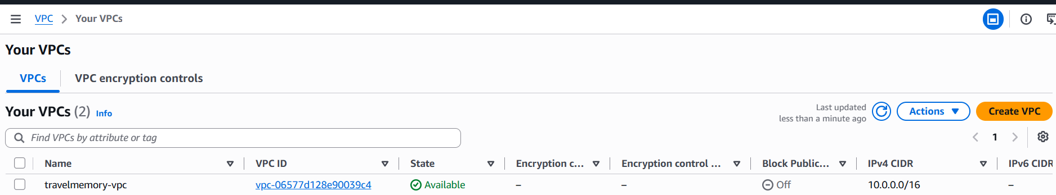
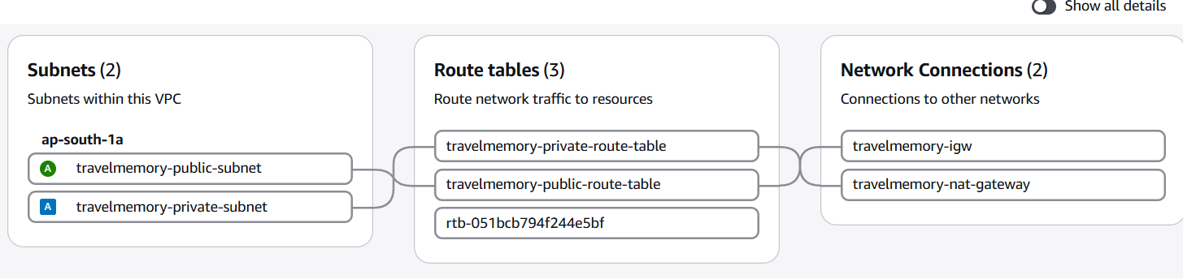
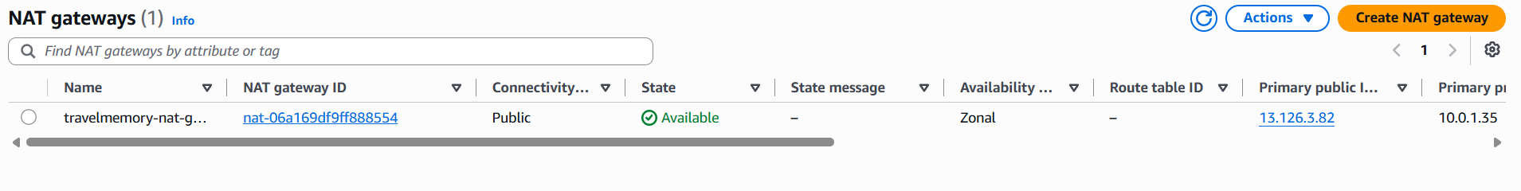
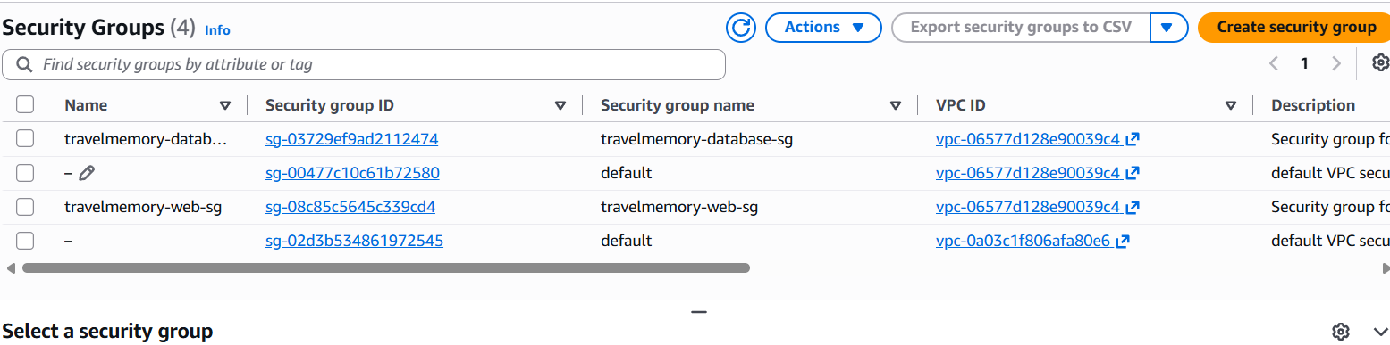
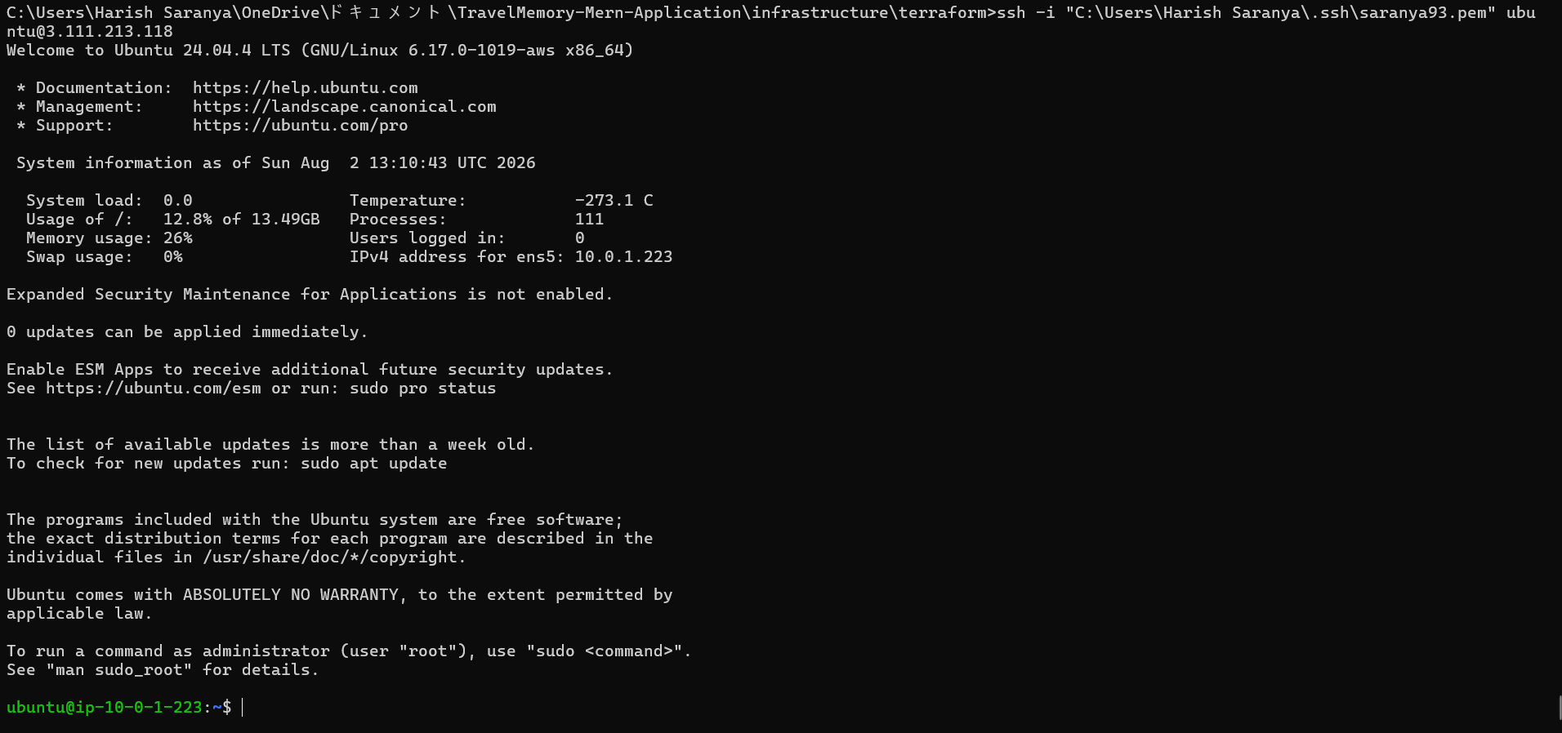
Configuration and Deployment with Ansible:
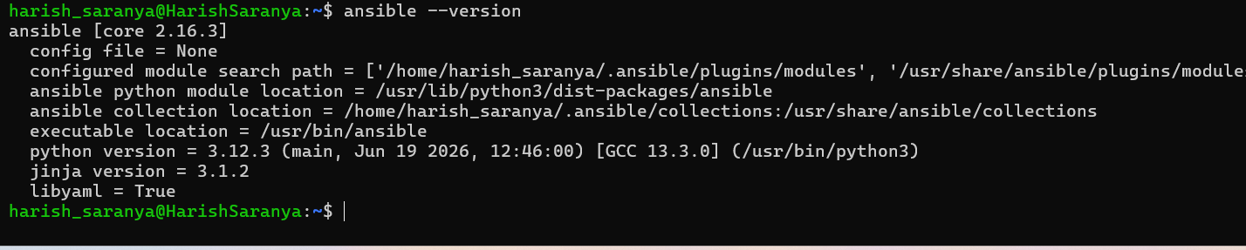
Create Ansible folders:
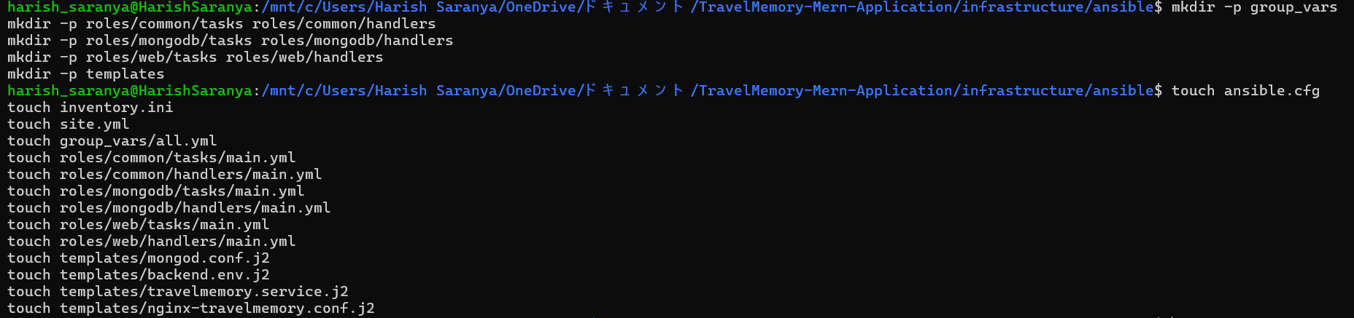
ansible.cfg:
[defaults]
inventory = inventory.ini
host_key_checking = False
retry_files_enabled = False
interpreter_python = auto_silent
timeout = 30
roles_path = roles
[ssh_connection]
pipelining = True

Ansible inventory:
[web]
web-server ansible_host=3.111.213.118 ansible_user=ubuntu
[database]
database-server ansible_host=10.0.2.143 ansible_user=ubuntu
[web:vars]
ansible_ssh_private_key_file=/home/harish_saranya/.ssh/saranya93.pem
[database:vars]
ansible_ssh_private_key_file=/home/harish_saranya/.ssh/saranya93.pem
ansible_ssh_common_args='-o ProxyJump=ubuntu@3.111.213.118 -o IdentityFile=/home/harish_saranya/.ssh/saranya93.pem -o StrictHostKeyChecking=no -o UserKnownHostsFile=/dev/null'
Create Ansible variables:
nano group_vars/all.yml
---
app_source_directory: "/mnt/c/Users/Harish Saranya/OneDrive/ドキュメント/TravelMemory-Mern-Application"
app_directory: "/opt/travelmemory"

backend_folder: "backend"
frontend_folder: "frontend"

backend_port: 3001

mongodb_database: "travelmemory"
mongodb_admin_user: "travelAdmin"
mongodb_admin_password: "TravelAdmin2026Strong"
mongodb_app_user: "travelApp"
mongodb_app_password: "TravelApp2026Strong"

database_private_ip: "10.0.2.143"
web_server_private_ip: "10.0.1.223"

public_subnet_cidr: "10.0.1.0/24"
private_subnet_cidr: "10.0.2.0/24"
Create Common Rules:
---
- name: Update apt package cache
ansible.builtin.apt:
update_cache: true
cache_valid_time: 3600

- name: Install common packages
ansible.builtin.apt:
name:
- curl
- git
- ca-certificates
- gnupg
- unzip
- ufw
state: present

- name: Disable root SSH login
ansible.builtin.lineinfile:
path: /etc/ssh/sshd_config
regexp: '^#?PermitRootLogin'
line: 'PermitRootLogin no'
validate: '/usr/sbin/sshd -t -f %s'
notify: Restart SSH
---
- name: Restart SSH
ansible.builtin.service:
name: ssh
state: restarted

Create MongoDB configuration:
storage:
dbPath: /var/lib/mongodb

systemLog:
destination: file
logAppend: true
path: /var/log/mongodb/mongod.log

net:
port: 27017
bindIp: 127.0.0.1,{{ database_private_ip }}

processManagement:
timeZoneInfo: /usr/share/zoneinfo

security:
authorization: enabled
Create MongoDB role:
---
- name: Install MongoDB prerequisites
ansible.builtin.apt:
name:
- curl
- gnupg
- ca-certificates
state: present
update_cache: true

- name: Download MongoDB signing key
ansible.builtin.get_url:
url: https://pgp.mongodb.com/server-8.0.asc
dest: /tmp/mongodb-server-8.0.asc
mode: "0644"

- name: Install MongoDB signing key
ansible.builtin.command:
cmd: >
gpg --dearmor
--yes
--output /usr/share/keyrings/mongodb-server-8.0.gpg
/tmp/mongodb-server-8.0.asc
args:
creates: /usr/share/keyrings/mongodb-server-8.0.gpg

- name: Add MongoDB repository
ansible.builtin.apt_repository:
repo: >-
deb [arch=amd64 signed-by=/usr/share/keyrings/mongodb-server-8.0.gpg]
https://repo.mongodb.org/apt/ubuntu
noble/mongodb-org/8.0 multiverse
filename: mongodb-org-8.0
state: present

- name: Install MongoDB
ansible.builtin.apt:
name: mongodb-org
state: present
update_cache: true

- name: Enable and start MongoDB without authentication initially
ansible.builtin.service:
name: mongod
state: started
enabled: true

- name: Wait until MongoDB is available
ansible.builtin.wait_for:
host: 127.0.0.1
port: 27017
timeout: 60

- name: Check whether MongoDB administrator exists
ansible.builtin.shell: |
mongosh --quiet --eval '
db.getSiblingDB("admin").getUser("{{ mongodb_admin_user }}")
'
register: mongodb_admin_check
changed_when: false
failed_when: false
no_log: true

- name: Create MongoDB administrator
ansible.builtin.shell: |
mongosh --quiet --eval '
db.getSiblingDB("admin").createUser({
user: "{{ mongodb_admin_user }}",
pwd: "{{ mongodb_admin_password }}",
roles: [
{
role: "root",
db: "admin"
}
]
})
'
when: mongodb_admin_user not in mongodb_admin_check.stdout
no_log: true

- name: Create application database user
ansible.builtin.shell: |
mongosh --quiet \
--username "{{ mongodb_admin_user }}" \
--password "{{ mongodb_admin_password }}" \
--authenticationDatabase admin \
--eval '
const applicationDatabase =
db.getSiblingDB("{{ mongodb_database }}");

if (!applicationDatabase.getUser("{{ mongodb_app_user }}")) {
applicationDatabase.createUser({
user: "{{ mongodb_app_user }}",
pwd: "{{ mongodb_app_password }}",
roles: [
{
role: "readWrite",
db: "{{ mongodb_database }}"
}
]
});
}
'
no_log: true

- name: Deploy secured MongoDB configuration
ansible.builtin.template:
src: mongod.conf.j2
dest: /etc/mongod.conf
owner: root
group: root
mode: "0644"
notify: Restart MongoDB

- name: Allow SSH from public subnet through UFW
community.general.ufw:
rule: allow
port: "22"
proto: tcp
src: "{{ public_subnet_cidr }}"

- name: Allow MongoDB from web server through UFW
community.general.ufw:
rule: allow
port: "27017"
proto: tcp
src: "{{ web_server_private_ip }}"

- name: Enable UFW with incoming traffic denied
community.general.ufw:
state: enabled
policy: deny
direction: incoming

---
- name: Restart MongoDB
ansible.builtin.service:
name: mongod
state: restarted
enabled: true

Create backend environment template:
PORT={{ backend_port }}
NODE_ENV=production
MONGO_URI=mongodb://{{ mongodb_app_user }}:{{ mongodb_app_password }}@{{ database_private_ip }}:27017/{{ mongodb_database }}?authSource={{ mongodb_database }}
Create backend systemd service:
[Unit]
Description=TravelMemory Express Backend
After=network.target

[Service]
Type=simple
User=ubuntu
Group=ubuntu
WorkingDirectory={{ app_directory }}/{{ backend_folder }}
EnvironmentFile={{ app_directory }}/{{ backend_folder }}/.env
ExecStart=/usr/bin/node {{ app_directory }}/{{ backend_folder }}/index.js
Restart=always
RestartSec=5
StandardOutput=journal
StandardError=journal

[Install]
WantedBy=multi-user.target
Create Nginx configuration:
server {
listen 80;
listen [::]:80;

server_name _;

root {{ app_directory }}/{{ frontend_folder }}/build;
index index.html;

location / {
try_files $uri $uri/ /index.html;
}

location /api/ {
proxy_pass http://127.0.0.1:{{ backend_port }}/;
proxy_http_version 1.1;

proxy_set_header Host $host;
proxy_set_header X-Real-IP $remote_addr;
proxy_set_header X-Forwarded-For $proxy_add_x_forwarded_for;
proxy_set_header X-Forwarded-Proto $scheme;
}
}
Create the web-server role:
ansible-galaxy collection install ansible.posix community.general
sudo apt install -y rsync
---
- name: Install Node.js prerequisites
ansible.builtin.apt:
name:
- curl
- ca-certificates
- gnupg
- nginx
- rsync
state: present
update_cache: true

- name: Add NodeSource repository
ansible.builtin.shell: |
curl -fsSL https://deb.nodesource.com/setup_22.x | bash -
args:
creates: /etc/apt/sources.list.d/nodesource.list

- name: Install Node.js
ansible.builtin.apt:
name: nodejs
state: present
update_cache: true

- name: Create application directory
ansible.builtin.file:
path: "{{ app_directory }}"
state: directory
owner: ubuntu
group: ubuntu
mode: "0755"

- name: Transfer application source to web server
ansible.posix.synchronize:
src: "{{ app_source_directory }}/"
dest: "{{ app_directory }}/"
recursive: true
delete: false
rsync_opts:
- "--exclude=.git"
- "--exclude=node_modules"
- "--exclude=infrastructure/terraform/.terraform"
- "--exclude=*.tfstate"
- "--exclude=*.tfplan"
- "--exclude=.env"
become: false

- name: Set application ownership
ansible.builtin.file:
path: "{{ app_directory }}"
state: directory
owner: ubuntu
group: ubuntu
recurse: true

- name: Install backend dependencies
community.general.npm:
path: "{{ app_directory }}/{{ backend_folder }}"
production: true
become_user: ubuntu

- name: Install frontend dependencies
community.general.npm:
path: "{{ app_directory }}/{{ frontend_folder }}"
become_user: ubuntu

- name: Create backend environment file
ansible.builtin.template:
src: backend.env.j2
dest: "{{ app_directory }}/{{ backend_folder }}/.env"
owner: ubuntu
group: ubuntu
mode: "0600"
notify: Restart TravelMemory

- name: Build React frontend
ansible.builtin.command:
cmd: npm run build
chdir: "{{ app_directory }}/{{ frontend_folder }}"
become_user: ubuntu
environment:
CI: "false"

- name: Install backend systemd service
ansible.builtin.template:
src: travelmemory.service.j2
dest: /etc/systemd/system/travelmemory.service
owner: root
group: root
mode: "0644"
notify:
- Reload systemd
- Restart TravelMemory

- name: Install Nginx configuration
ansible.builtin.template:
src: nginx-travelmemory.conf.j2
dest: /etc/nginx/sites-available/travelmemory
owner: root
group: root
mode: "0644"
notify: Restart Nginx

- name: Enable TravelMemory Nginx configuration
ansible.builtin.file:
src: /etc/nginx/sites-available/travelmemory
dest: /etc/nginx/sites-enabled/travelmemory
state: link
notify: Restart Nginx

- name: Remove default Nginx configuration
ansible.builtin.file:
path: /etc/nginx/sites-enabled/default
state: absent
notify: Restart Nginx

- name: Validate Nginx configuration
ansible.builtin.command:
cmd: nginx -t
changed_when: false

- name: Enable and start backend
ansible.builtin.systemd:
name: travelmemory
enabled: true
state: started
daemon_reload: true

- name: Enable and start Nginx
ansible.builtin.service:
name: nginx
enabled: true
state: started

- name: Permit SSH through UFW
community.general.ufw:
rule: allow
port: "22"
proto: tcp

- name: Permit HTTP through UFW
community.general.ufw:
rule: allow
port: "80"
proto: tcp

- name: Enable UFW with incoming traffic denied
community.general.ufw:
state: enabled
policy: deny
direction: incoming
Create Handlers:
---
- name: Reload systemd
ansible.builtin.systemd:
daemon_reload: true

- name: Restart TravelMemory
ansible.builtin.service:
name: travelmemory
state: restarted
enabled: true

- name: Restart Nginx
ansible.builtin.service:
name: nginx
state: restarted
enabled: true
Create main playbook:
---
- name: Apply common configuration
hosts: all
become: true
roles:
- common

- name: Configure private MongoDB server
hosts: database
become: true
roles:
- mongodb

- name: Deploy TravelMemory application
hosts: web
become: true
roles:
- web
Verify:
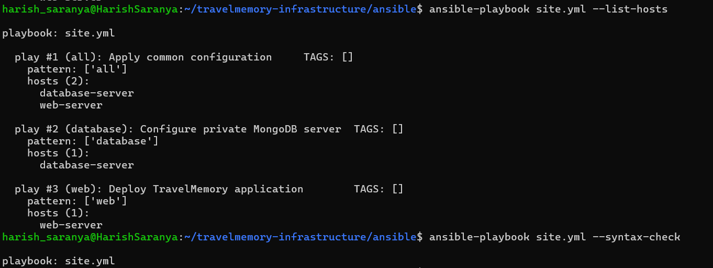

harish_saranya@HarishSaranya:~/travelmemory-infrastructure/ansible$ ansible-playbook site.yml --limit database

PLAY [Apply common configuration] **************************************************************************************************************************

TASK [Gathering Facts] *************************************************************************************************************************************
ok: [database-server]

TASK [common : Update apt package cache] *******************************************************************************************************************
changed: [database-server]

TASK [common : Install common packages] ********************************************************************************************************************
changed: [database-server]

TASK [common : Disable root SSH login] *********************************************************************************************************************
[WARNING]: Module remote_tmp /root/.ansible/tmp did not exist and was created with a mode of 0700, this may cause issues when running as another user. To
avoid this, create the remote_tmp dir with the correct permissions manually
changed: [database-server]

RUNNING HANDLER [common : Restart SSH] *********************************************************************************************************************
changed: [database-server]

PLAY [Configure private MongoDB server] ********************************************************************************************************************

TASK [Gathering Facts] *************************************************************************************************************************************
ok: [database-server]

TASK [mongodb : Install MongoDB prerequisites] *************************************************************************************************************
ok: [database-server]

TASK [mongodb : Download MongoDB signing key] **************************************************************************************************************
changed: [database-server]

TASK [mongodb : Install MongoDB signing key] ***************************************************************************************************************
changed: [database-server]

TASK [mongodb : Add MongoDB repository] ********************************************************************************************************************
changed: [database-server]

TASK [mongodb : Install MongoDB] ***************************************************************************************************************************
changed: [database-server]

TASK [mongodb : Enable and start MongoDB without authentication initially] *********************************************************************************
changed: [database-server]

TASK [mongodb : Wait until MongoDB is available] ***********************************************************************************************************
ok: [database-server]

TASK [mongodb : Check whether MongoDB administrator exists] ************************************************************************************************
ok: [database-server]

TASK [mongodb : Create MongoDB administrator] **************************************************************************************************************
changed: [database-server]

TASK [mongodb : Create application database user] **********************************************************************************************************
changed: [database-server]

TASK [mongodb : Deploy secured MongoDB configuration] ******************************************************************************************************
changed: [database-server]

TASK [mongodb : Allow SSH from public subnet through UFW] **************************************************************************************************
changed: [database-server]

TASK [mongodb : Allow MongoDB from web server through UFW] *************************************************************************************************
changed: [database-server]

TASK [mongodb : Enable UFW with incoming traffic denied] ***************************************************************************************************
changed: [database-server]

RUNNING HANDLER [mongodb : Restart MongoDB] ****************************************************************************************************************
changed: [database-server]

PLAY [Deploy TravelMemory application] *********************************************************************************************************************
skipping: no hosts matched

PLAY RECAP *************************************************************************************************************************************************
database-server : ok=21 changed=16 unreachable=0 failed=0 skipped=0 rescued=0 ignored=0

harish_saranya@HarishSaranya:~/travelmemory-infrastructure/ansible$
